**Project Design Phase-II**

**Data Flow Diagram & User Stories**

|  |  |
| --- | --- |
| Date | 28 October 2022 |
| Team ID | PNT2022TMID17711 |
| Project Name | Project - Smart Waste Management System For Metropolitan City |
| Maximum Marks | 4 Marks |

**Data Flow Diagrams:**

A rapid rise in inhabitants across the globe has led to the inadmissible management of waste in various countries, giving rise to various health issues and environmental pollution. The waste-collecting trucks collect waste just once or twice in seven days. Due to improper waste collection practices, the waste in the dustbin is spread on the streets.

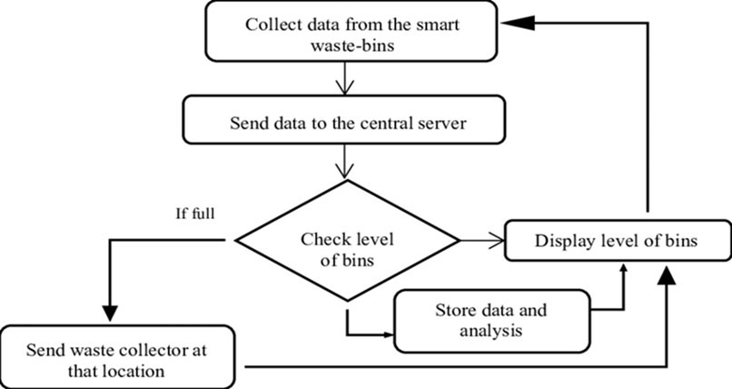

**User Stories**

